Adding Dense Layers

|  |  |
| --- | --- |
| DATE | 21 October 2022 |
| TEAM ID | PNT2022TMID30482 |
| PROJECT NAME | AI-powered Nutrition Analyzer for Fitness Enthusiasts |

A dense layer is a deeply connected neural network layer. It is the mostcommon and frequently used layer.

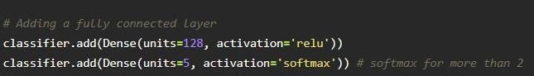

The number of neurons in the Dense layer is the same as the number of classes in the training set. The neurons in the last Dense layer, use softmaxactivation to convert their outputs into respective probabilities.

Understanding the model is a very important phase to properly using it fortraining and prediction purposes. Keras provides a simple method, a summary to get the full information about the model and its layers.

